SVM:
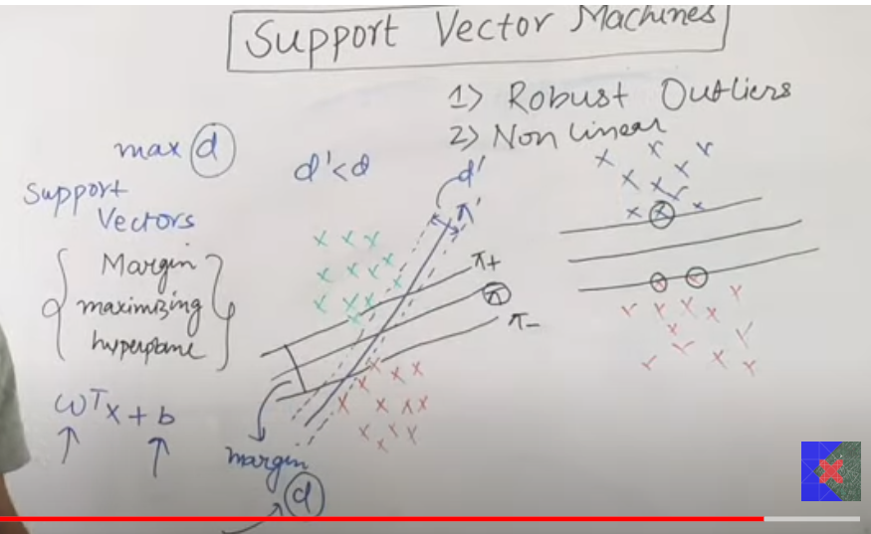
Support Vector Machines in classification tries to make a line (2d) or a hyperplane that classifies the two or three categories in such a way that the line cleanly classifies the categories and the distance between the first data point of categories d is maximum. So, it also uses gradient descent technique, to find the value of weights in such a way that maximizes the d (distance between the first point of each class)

Decision Rule:
For binary classification if wTx + b > 0 than my data point belongs to positive class and if wTx + b < 0, than the new data point belongs to negative class.

Key points:
- Robust to outliers
- Applicable to Non-linear data (using kernels we can solve non-linearity)

Hard magin SVM:
Hard margin svm fails to perform when the data is not linearly separable or there is impurity in the data, like some positive data points ar ein negative region an vice verse. And when the data is non-linear it also fails to perform there. To solve this problem there is extension of svm called soft margin

C in soft margin:
The greater the C the less will be the margin or d, or the lesser C the more margin or d.

Non-linear Problems:
For non-linear problems we do not use linear kernel, we use rbf kernel, poly kernel or others. RBF kernel applies a transformation to the data, that adds another axis z (if 2 d), and adding this feature the becomes separable in higher dimension

